Right Wedge

Definition
# Source: AI Source: Provided by: [Data Path: Persons Table -> ID Column: 1, Name_En Column: Motasem Essam] -> From: [ChatGPT] on [7/25/2026]
A Right Wedge is a three-dimensional geometric solid formed as a special type of wedge in which the triangular end faces are perpendicular to the rectangular base.
It has two parallel, congruent right-triangular end faces connected by three rectangular lateral faces.
The solid resembles a triangular prism with a right-triangular cross-section.
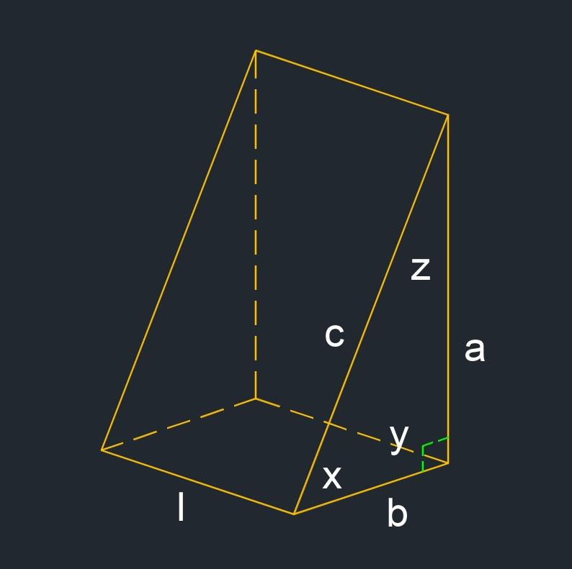
<caption>Right triangular wedge – three-dimensional geometric representation.</caption>
Terminology note: Here, “right wedge” means a wedge with right-triangular ends, also called a right triangular wedge. This is different from the general right wedge convention in some mathematical references, which describes a right triangular prism resting on a rectangular lateral face.

Simple Definition
# Source: AI Source: Provided by: [Data Path: Persons Table -> ID Column: 1, Name_En Column: Motasem Essam] -> From: [ChatGPT] on [7/25/2026]
A right wedge is a wedge-shaped solid with two congruent right-triangular ends and three rectangular lateral faces.
It has 5 faces, 9 edges, and 6 vertices.

Geometric Structure
# Source: AI Source: Provided by: [Data Path: Persons Table -> ID Column: 1, Name_En Column: Motasem Essam] -> From: [ChatGPT] on [7/25/2026]
The right wedge consists of three main structural components:
- First right-triangular face: One triangular end of the solid.
- Second right-triangular face: The opposite, congruent triangular end.
- Three rectangular lateral faces: Connect the corresponding edges of the two triangular ends.
The two triangular faces are parallel, and the connecting edges are perpendicular to their planes.
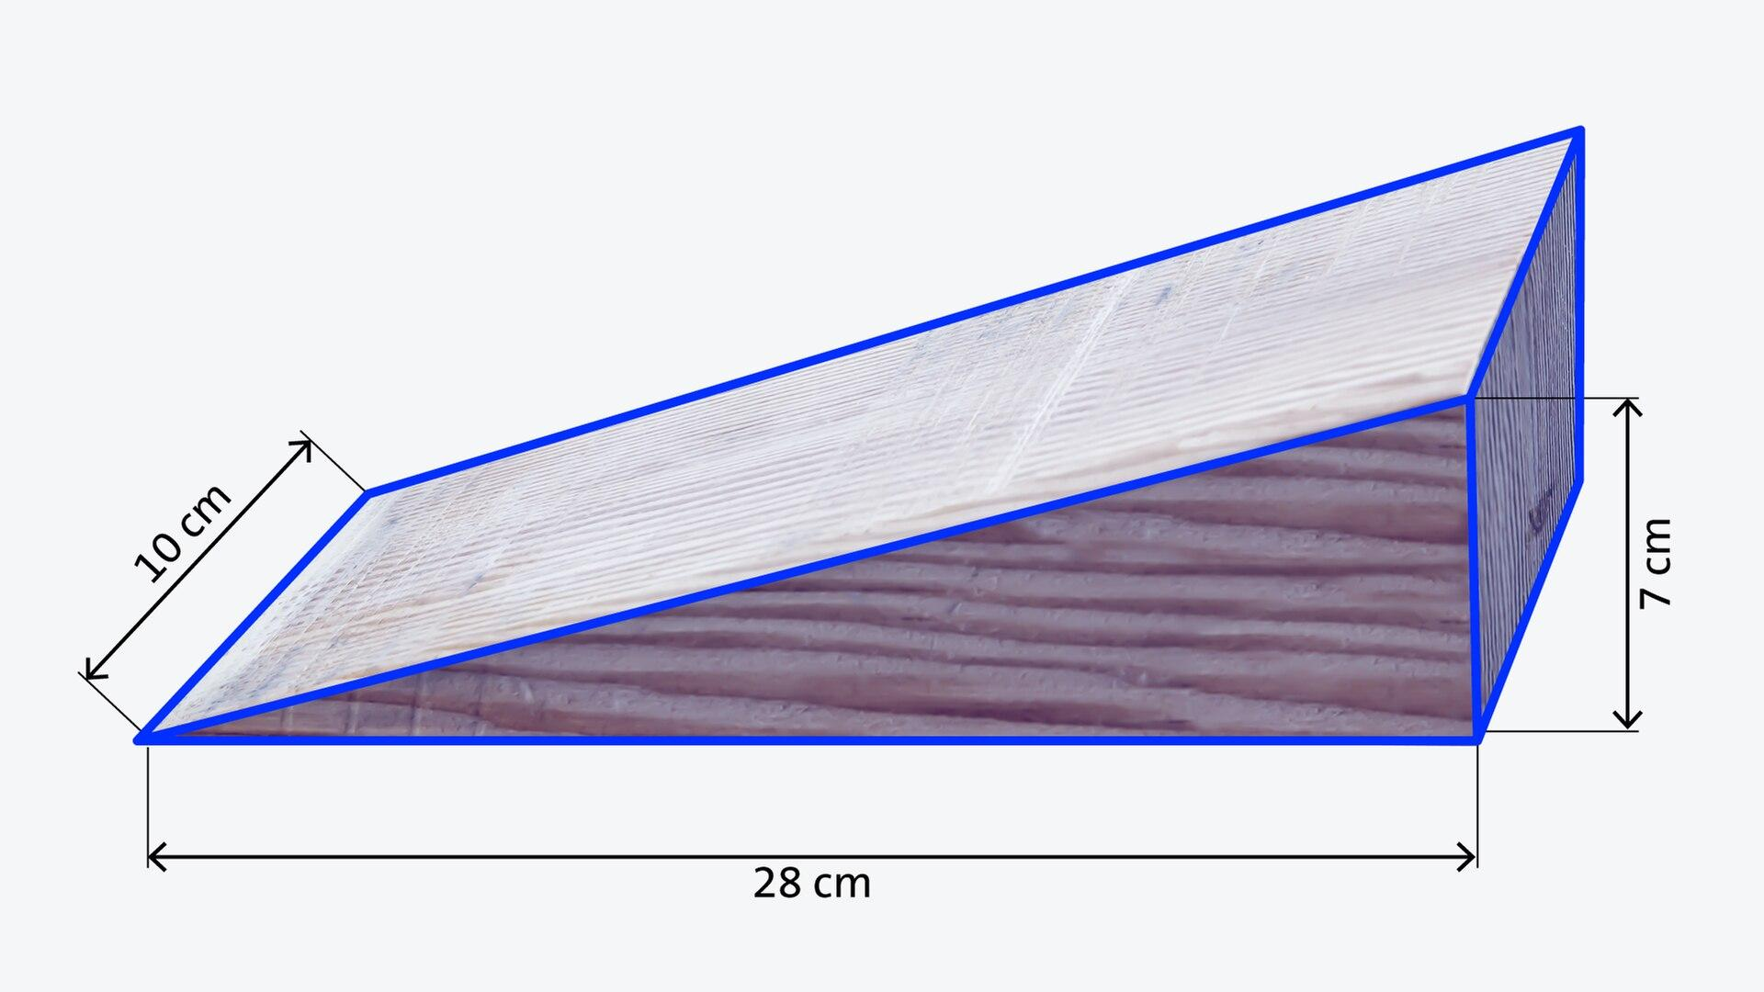

Face Structure
# Source: AI Source: Provided by: [Data Path: Persons Table -> ID Column: 1, Name_En Column: Motasem Essam] -> From: [ChatGPT] on [7/25/2026]
A right wedge has 5 faces.
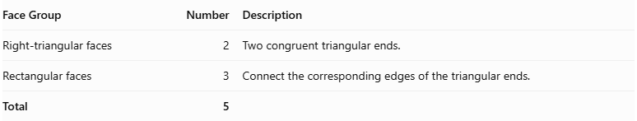
Face Group | Number | Description
Right-triangular faces | 2 | Two congruent triangular ends.
Rectangular faces | 3 | Connect the corresponding edges of the triangular ends.
Total | 5
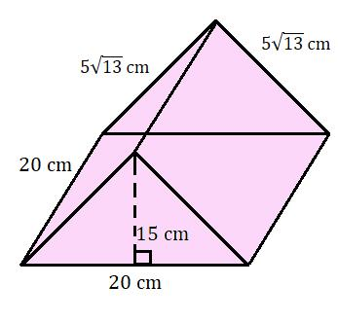

Edge Structure
# Source: AI Source: Provided by: [Data Path: Persons Table -> ID Column: 1, Name_En Column: Motasem Essam] -> From: [ChatGPT] on [7/25/2026]
A right wedge has 9 edges.
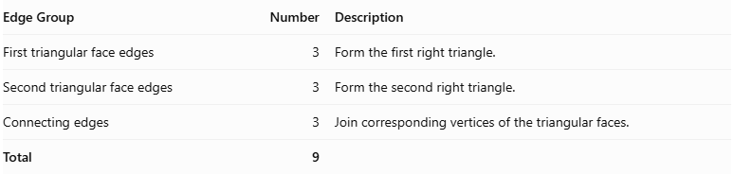
Edge Group | Number | Description
First triangular face edges | 3 | Form the first right triangle.
Second triangular face edges | 3 | Form the second right triangle.
Connecting edges | 3 | Join corresponding vertices of the triangular faces.
Total | 9

Vertex Structure
# Source: AI Source: Provided by: [Data Path: Persons Table -> ID Column: 1, Name_En Column: Motasem Essam] -> From: [ChatGPT] on [7/25/2026]
A right wedge has 6 vertices.
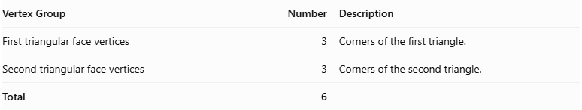
Vertex Group | Number | Description
First triangular face vertices | 3 | Corners of the first triangle.
Second triangular face vertices | 3 | Corners of the second triangle.
Total | 6

Mathematical Properties
# Source: AI Source: Provided by: [Data Path: Persons Table -> ID Column: 1, Name_En Column: Motasem Essam] -> From: [ChatGPT] on [7/25/2026]
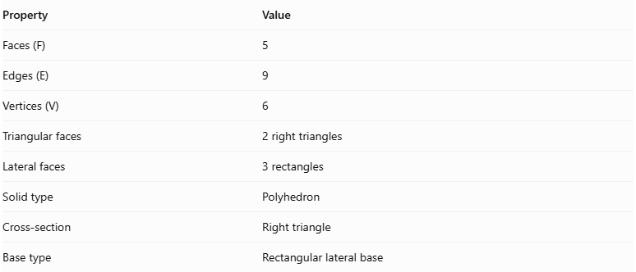
Property | Value
Faces (F) | 5
Edges (E) | 9
Vertices (V) | 6
Triangular faces | 2 right triangles
Lateral faces | 3 rectangles
Solid type | Polyhedron
Cross-section | Right triangle
Base type | Rectangular lateral base
It satisfies Euler's polyhedron formula:
$$V-E+F=2$$
Substituting:
$$6-9+5=2$$
Therefore, the right wedge satisfies Euler's formula.

Surface Area
# Source: AI Source: Provided by: [Data Path: Persons Table -> ID Column: 1, Name_En Column: Motasem Essam] -> From: [ChatGPT] on [7/25/2026]
The total surface area is the sum of the areas of the two right-triangular faces and the three rectangular lateral faces.
$$S=2A_{t}+A_{r1}+A_{r2}+A_{r3}$$
For a right-triangular wedge, let:
- $a$ = first perpendicular side of the triangular end.
- $b$ = second perpendicular side.
- $c$ = hypotenuse.
- $l$ = length of the wedge.
The area of each triangular face is:
$$A_{t}=\frac{1}{2}ab$$
The three rectangular faces have areas:
$$A_{r1}=al$$
$$A_{r2}=bl$$
$$A_{r3}=cl$$
Therefore:
$$S=2\left(\frac{1}{2}ab\right)+al+bl+cl$$
$$\boxed{S=ab+l(a+b+c)}$$

Volume
# Source: AI Source: Provided by: [Data Path: Persons Table -> ID Column: 1, Name_En Column: Motasem Essam] -> From: [ChatGPT] on [7/25/2026]
The volume of a right wedge is calculated by multiplying the area of its right-triangular cross-section by its length.
$$V=A_{t}×l$$
Since:
$$A_{t}=\frac{1}{2}ab$$
Therefore:
$$\boxed{V=\frac{1}{2}abl}$$
Where:
- $a$ = first perpendicular side of the triangular cross-section.
- $b$ = second perpendicular side.
- $l$ = length of the wedge.
The hypotenuse can be calculated using the Pythagorean theorem:
$$\boxed{c=\sqrt{a^{2}+b^{2}}}$$

Symmetry
# Source: AI Source: Provided by: [Data Path: Persons Table -> ID Column: 1, Name_En Column: Motasem Essam] -> From: [ChatGPT] on [7/25/2026]
A right wedge has symmetry properties determined by the shape of its right-triangular cross-section.
- Longitudinal symmetry: The two triangular ends are congruent and parallel.
- Reflection symmetry: An isosceles right-triangular cross-section gives the solid a longitudinal plane of reflection symmetry.
- Rotational symmetry: A general right wedge does not have continuous rotational symmetry.
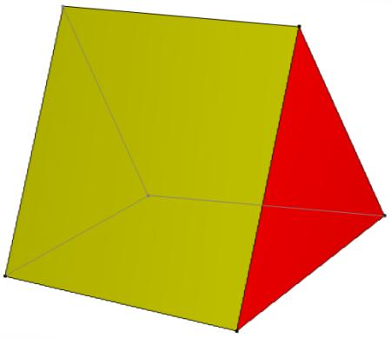

Relationship to Other Solids
# Source: AI Source: Provided by: [Data Path: Persons Table -> ID Column: 1, Name_En Column: Motasem Essam] -> From: [ChatGPT] on [7/25/2026]
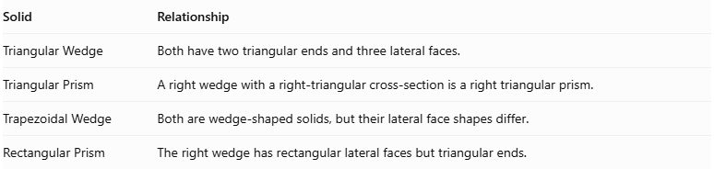
Solid | Relationship
Triangular Wedge | Both have two triangular ends and three lateral faces.
Triangular Prism | A right wedge with a right-triangular cross-section is a right triangular prism.
Trapezoidal Wedge | Both are wedge-shaped solids, but their lateral face shapes differ.
Rectangular Prism | The right wedge has rectangular lateral faces but triangular ends.
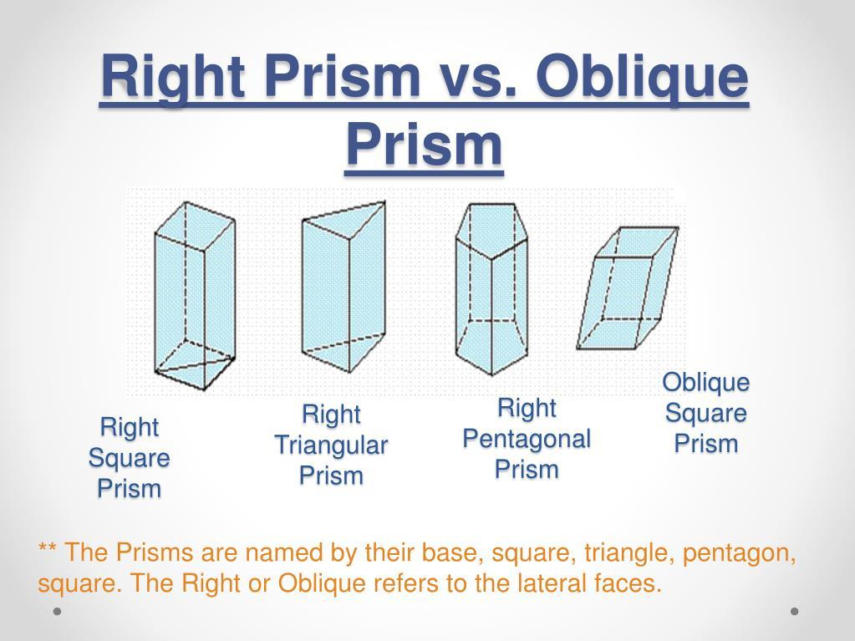

Worked Examples

Example 1: Calculate Faces, Edges, and Vertices
# Source: AI Source: Provided by: [Data Path: Persons Table -> ID Column: 1, Name_En Column: Motasem Essam] -> From: [ChatGPT] on [7/25/2026]
A right wedge has:
- 2 right-triangular faces.
- 3 rectangular faces.
- 9 edges.
- 6 vertices.
Therefore:
$$F=2+3=5$$
$$E=9$$
$$V=6$$

Example 2: Calculate Volume
# Source: AI Source: Provided by: [Data Path: Persons Table -> ID Column: 1, Name_En Column: Motasem Essam] -> From: [ChatGPT] on [7/25/2026]
Given:
- $a=6\text{ cm}$
- $b=8\text{ cm}$
- $l=10\text{ cm}$
Using:
$$V=\frac{1}{2}abl$$
Substituting:
$$V=\frac{1}{2}(6)(8)(10)$$
$$V=240$$
$$\boxed{V=240{\text{ cm}}^{3}}$$

Example 3: Calculate Surface Area
# Source: AI Source: Provided by: [Data Path: Persons Table -> ID Column: 1, Name_En Column: Motasem Essam] -> From: [ChatGPT] on [7/25/2026]
Using the same dimensions:
$$c=\sqrt{6^{2}+8^{2}}$$
$$c=\sqrt{100}=10\text{ cm}$$
The surface area is:
$$S=ab+l(a+b+c)$$
$$S=(6)(8)+10(6+8+10)$$
$$S=48+240$$
$$\boxed{S=288{\text{ cm}}^{2}}$$

Constructing Right Wedge in Solid Geometry

Geometric Instruments Used
# Source: AI Source: Provided by: [Data Path: Persons Table -> ID Column: 1, Name_En Column: Motasem Essam] -> From: [ChatGPT] on [7/25/2026]
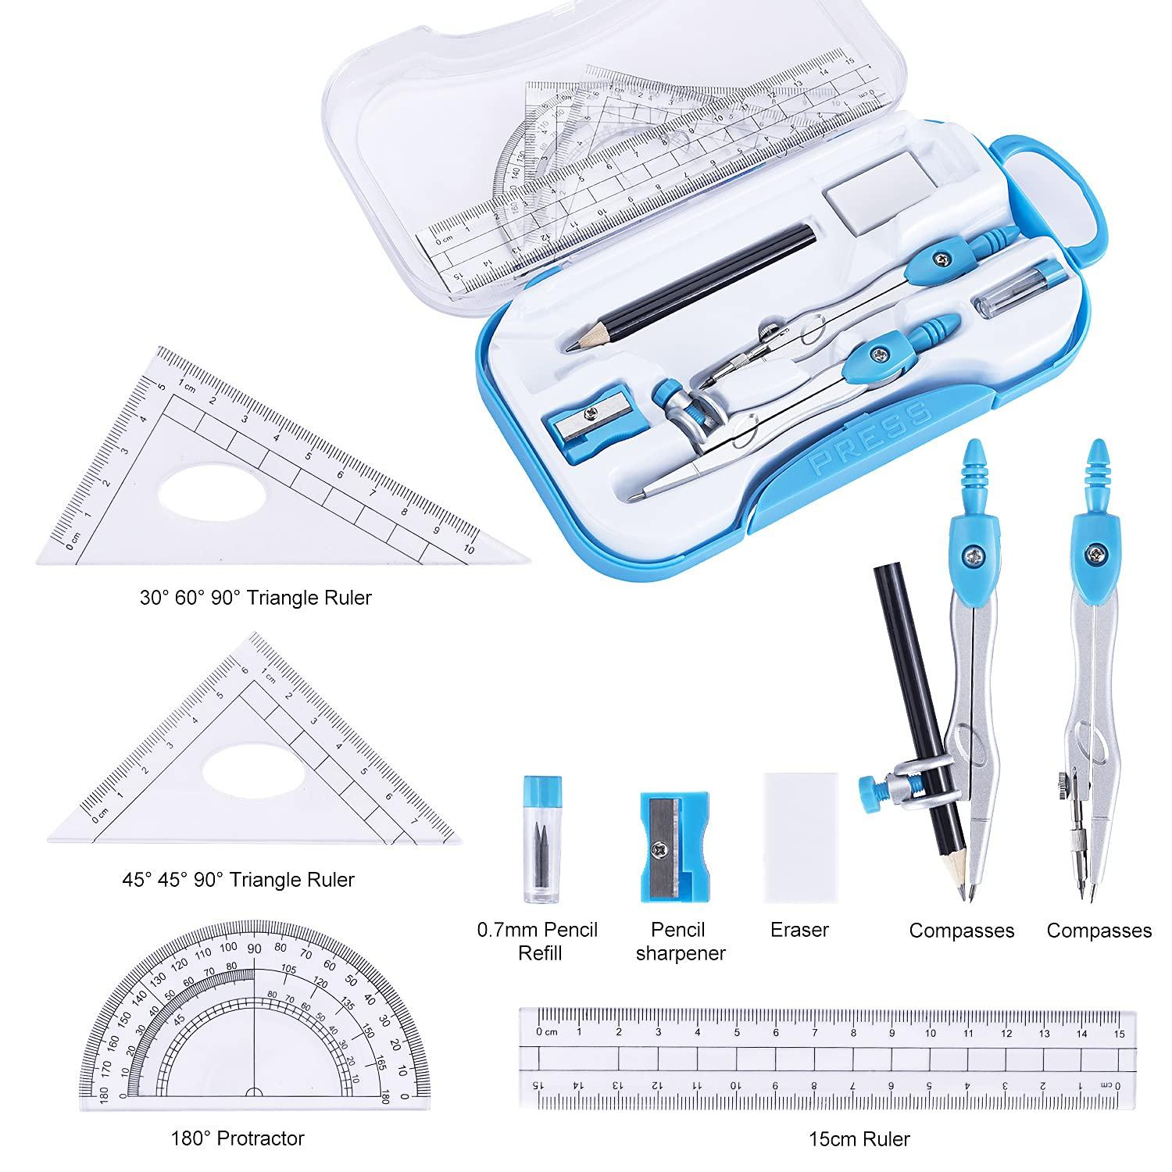
- Ruler: Drawing straight edges.
- Compass: Drawing arcs and transferring distances.
- Protractor: Measuring angles.
- Set square: Constructing right angles.
- Pencil: Drawing construction lines.
- Eraser: Removing unnecessary construction marks.

Instrument-Based Construction Procedures

A. Constructing the First Right-Triangular Face
# Source: AI Source: Provided by: [Data Path: Persons Table -> ID Column: 1, Name_En Column: Motasem Essam] -> From: [ChatGPT] on [7/25/2026]
- Draw a horizontal line representing the first perpendicular side.
- Use a set square to construct a perpendicular line.
- Mark the required dimensions of the two perpendicular sides.
- Connect their endpoints to form the hypotenuse.
- Complete the right-triangular face.

B. Constructing the Second Right-Triangular Face
# Source: AI Source: Provided by: [Data Path: Persons Table -> ID Column: 1, Name_En Column: Motasem Essam] -> From: [ChatGPT] on [7/25/2026]
- Draw a second right triangle parallel to the first.
- Make both triangles congruent.
- Position the second triangle at the required distance from the first.
- Label the corresponding vertices.

C. Connecting the Two Triangular Faces
# Source: AI Source: Provided by: [Data Path: Persons Table -> ID Column: 1, Name_En Column: Motasem Essam] -> From: [ChatGPT] on [7/25/2026]
- Connect the corresponding vertices of both triangles.
- Construct the three rectangular lateral faces.
- Ensure that the connecting edges are perpendicular to the triangular end faces.
- Complete the solid outline.

D. Completing the Right Wedge
# Source: AI Source: Provided by: [Data Path: Persons Table -> ID Column: 1, Name_En Column: Motasem Essam] -> From: [ChatGPT] on [7/25/2026]
- Check that the solid has two congruent right-triangular faces.
- Check that it has three rectangular lateral faces.
- Darken the visible edges.
- Draw hidden edges using dashed lines when necessary.
- Remove unnecessary construction marks.
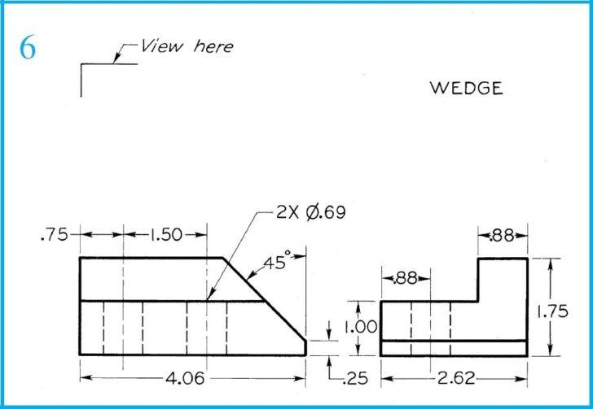

Key Points
# Source: AI Source: Provided by: [Data Path: Persons Table -> ID Column: 1, Name_En Column: Motasem Essam] -> From: [ChatGPT] on [7/25/2026]
- A right wedge has two congruent right-triangular end faces.
- It has three rectangular lateral faces.
- It has 5 faces in total.
- It has 9 edges.
- It has 6 vertices.
- Its triangular cross-section contains a 90-degree angle.
- Its surface area is the sum of the areas of all five faces.
- Its volume is half the product of the two perpendicular triangular sides and the wedge length.

Conclusion
# Source: AI Source: Provided by: [Data Path: Persons Table -> ID Column: 1, Name_En Column: Motasem Essam] -> From: [ChatGPT] on [7/25/2026]
A Right Wedge is a three-dimensional geometric solid consisting of two congruent right-triangular faces connected by three rectangular lateral faces. It has 5 faces, 9 edges, and 6 vertices.
Its defining characteristic is its right-triangular cross-section and perpendicular connecting edges, distinguishing it from other wedge configurations.

Image and reference sources
# Source: AI Source: Provided by: [Data Path: Persons Table -> ID Column: 1, Name_En Column: Motasem Essam] -> From: [ChatGPT] on [7/25/2026]
- Right Triangle Wedge – Piping Designer — triangular ends, rectangular faces, surface area, and volume formulas.
- Wedge – Wolfram MathWorld — mathematical definition and distinction between right and oblique wedges.
- Right Wedge – RedCrab Software — geometric properties and Euler's formula.
- Solid Geometry – Piping Designer — classification of right triangular wedges.

